i-Factor Project
Platform interface content

Table of Contents

1. About i-Factor Platform/Homepage (page 1) 1
1.1 Some statements to be designed on the homepage 1
1.2 Our Commitment 1
1.3 I need Financing/Become a Seller – Join now 2
1.4 I want to Invest/Become a Buyer – Join now 2
2. How it works (page 2) 3
2.1 How many parties are involved on i-Factor platform 3
2.2 How it works 3
3. Contact us (page 3) 4
4. Cookie Policy (page 4) 5
5. Terms of Use (page 5) 6
5.1 Copyright 6
5.2 Linking 6
5.3 Governing Law 6
5.4 Privacy Policy 6
6. Login page (page 6) 7
7. Click on “I need Financing” (page 7) 9
7.1 SME Registration UI 9
8. Click on “I want to Invest” (page 8) 10
8.1 Buyer Registration UI 10

- About i-Factor Platform/Homepage (page 1)
  - Some statements to be designed on the homepage
refer to http://www.platformblack.com/platform-black/
http://marketinvoice.com/

Design some blocks to demonstrate these 3. Pls have open function to edit the word

- Factor platform was founded by EntroFine Consulting Ltd. (“EntroFine”) , the simple solution for invoice trading. →title

i-Factor is an Innovative Business Solution to flexible finance, which utilizes an online invoice-trading platform that allows your company to sell individual outstanding invoices to the investors at a competitive rate. This innovation allows your company to get financed in the most efficient way! →word

- The platform is managed by Vietnam Prosperity Bank (“VPBank”), thus ensuring a secured transaction process. →title

i-Factor is first implemented in Vietnam market from October 2014 and operated by VPBank. The platform offers an efficient and flexible alternative to traditional financing products, whose aim is to help your company to secure the liquidity you need to finance your day-to-day businesses without any collaterals. →word

- I-Factor platform works for you→title
Sellers →small title
Our innovation trading platform provides a straightforward way to turn your outstanding invoices into ready cash for your businesses. →word

Investors→small title
i-Factor offers a new secured investment environment, which provide investors with the opportunity to diversify their asset portfolio with competitive return. →word

  - Our Commitment
- Speed and flexibility
- No lock-in, lock-up
- Simple and quick processes, no lengthy banking application processes.
- Transparency and security
- Transparent cost and return structures
- Secured payment processes
- Efficiency and competitive pricing
- No collaterals required
- Guaranteed lower costs than traditional factoring services

  - I need Financing/Become a Seller – Join now
→ UI registration page for Sellers
  - I want to Invest/Become a Buyer – Join now
→ UI registration page for Buyers

- How it works (page 2)
  - How many parties are involved on i-Factor platform
Use different picture/icon to demonstrate these 3 parties
Refer to http://www.platformblack.com/platform-black/

- Small-and-medium-sized Enterprises (SMEs) or Micro Small-and-medium-sized Enterprises (MSMEs) →title
For those whose need is to raise fast and flexible liquidity against long-dated invoices. This party is referred to as the SELLERs.
- Investors →title
For the banks, hedge funds, private equity firms, or high net worth individuals, etc., whose objective is to invest in a totally new but secure, high yield and short duration asset class. This party is referred to as the INVESTORs.
- Vietnam Prosperity Bank (“VPBank”) →title
The operator of the platform, who performs the intermediation role, manage and secure the auction, transaction and payment processes.

  - How it works
Make the below into a flow

- Apply as a Seller or as an Investor on i-Factor platform quickly and simply according to the position that suites your needs.
- As a Seller, you are ready upload invoices you would like to sell for auction once your application is approved.
- As an Investor, you benefit from the opportunity of a short-term investment, facing low risks and accruing competitive returns, all using our online platform.
- The auction is closed when Sellers accept the conditions offered by Buyers.
- The platform intermediates all successful transactions, instructing settlement and payment terms. Unlike investors who do not meet face to face with Sellers, i-Factor interacts with both parties and operates each transaction by online trading platform.

- Contact us (page 3)

Pls have a look the below website “contact us” and make one for this website or just use entrofine’s “contact us”.

http://www.platformblack.com/contact/
http://marketinvoice.com/about/contact/
http://www.entrofine.com/contact.aspx
http://www.intedelta.com/contact-us

- Office address
- Telephone
- Email
- etc

- Cookie Policy (page 4)
Pls have open function for us to edit the content later on.
Our website uses cookies to provide you the best possible experience. We use four types of cookies:
- Basic operational cookies: These cookies are essential for the operation of our system, allowing you to smoothly move around our website.
- Functionally cookies: We use functionally cookies to allow us to remember your preferences. Cookies save you the trouble of typing in your username every time you access the website. We also use functionally cookies to allow you to watch video online. These cookies expire after 6 months unless you delete them.
- Performance cookies: These cookies let us collect important information on how our website is used, allowing us to quickly identify and fix any issues that arise. All of this information is collected anonymously, and actions cannot be tied to the identity of individual users. These cookies expire after 6 months unless you delete them.
- Targeting cookies: These cookies allow us to track which users have visited our page. They expire after 6 months unless you delete them.
- Terms of Use (page 5)
Pls have open function for us to edit the content later on.
  - Copyright
Copyright of the content of this website is owned by Entrofine Consulting Ltd (“EntroFine”).
Any storage, copying, transmission or distribution of the content or the publications in this website is prohibited without the consent of EntroFine. Please contact us at info@entrofine.com for more information.
  - Linking
Electronic links to this site are prohibited without the consent of Entrofine and VPBank Group. Please address requests to EntroFine at info@entrofine.com for more information.
We do not endorse or accept any responsibility for any content on or software downloaded from any website linked from this website.
  - Governing Law
This legal notice and all issues regarding this website are governed by Vietnamese Law and any disputes arising hereunder will be subject to the exclusive jurisdiction of the Supreme People’s Court of Vietnam.
  - Privacy Policy
Personal data submitted on this website will be used for the purposes specified in the relevant part of the website and for other purposes for which you give your consent.
When you access our website, your computer’s browser provides us your IP address, browser type, access time and referring URL which is collected and used to compile statistical data on the use of our website. This statistical data may be used to help us to improve our website and the services we offer. Cookies must be enabled on your browser.

- Login page (page 6)
→ Login page
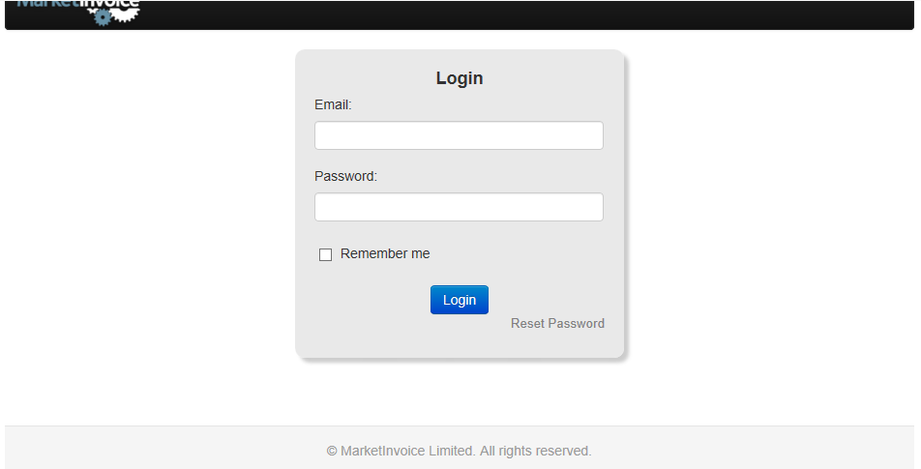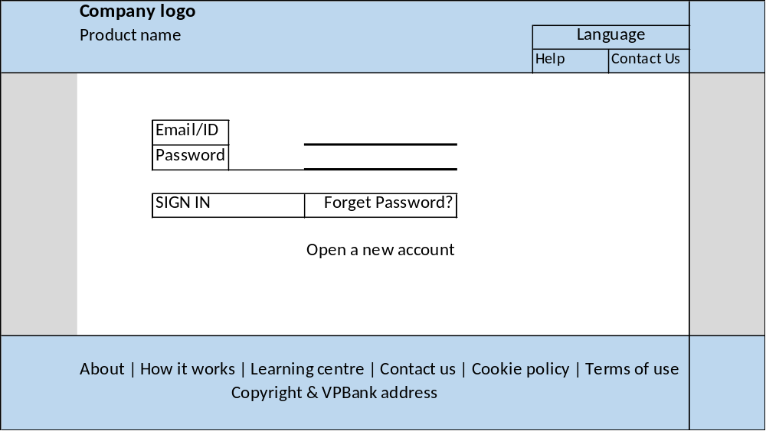
Click on “Join Us”
- Option 1: Go down to “I need Financing” or “I want to Invest”
→it’s difficult to stop at accurate place

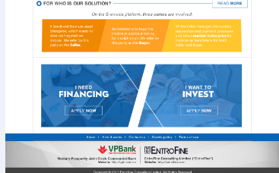

- Click on “I need Financing” (page 7)
  - SME Registration UI
- Pop-up legal disclaimer for SME registration
Button: I Agree; I Disagree

- I need Financing
Thank you for choosing to register in i-Factor platform

- For the existing users, please click below.
Button: Resume an existing application

Register Now
Please fill in and submit the registration form below to begin your application.
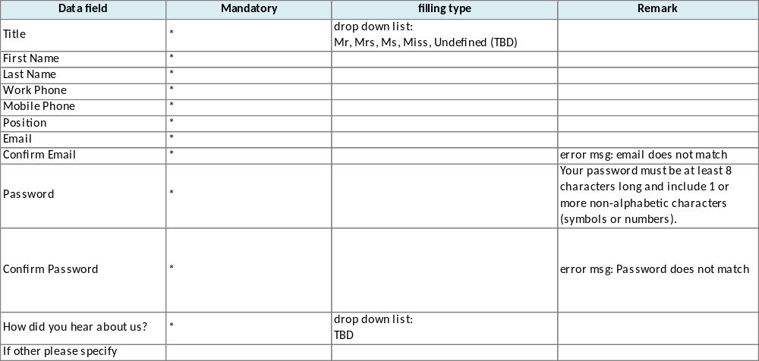

Button: Register

- Click on “I want to Invest” (page 8)
  - Buyer Registration UI
- Pop-up legal disclaimer for SME registration
Button: I Agree; I Disagree

- I want to Invest
Thank you for choosing to register in i-Factor platform

- For the existing users, please click below.
Button: Resume an existing application

Register Now
Please fill in and submit the registration form below to begin your application.
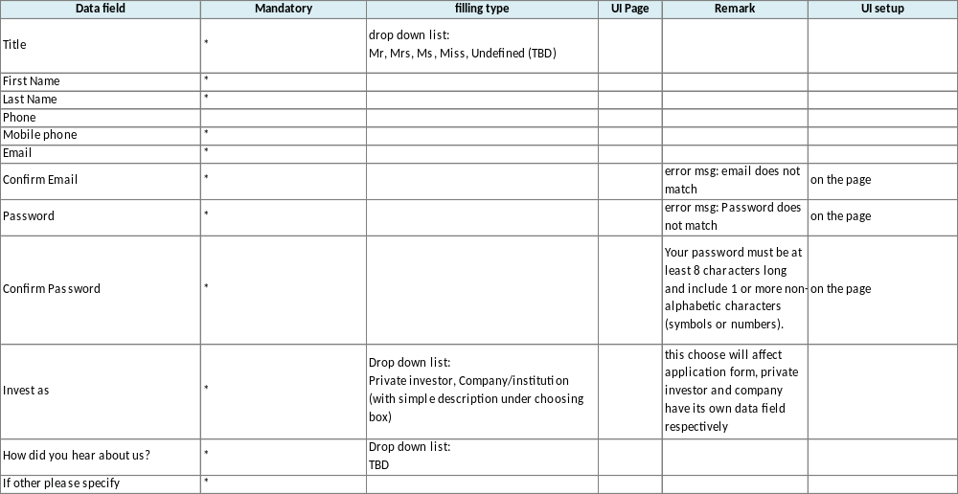

- Button: Register

 | Sophisticated Investor - Self-certified sophisticated investors must have experience in dealing with invoice finance or similar products or have a track record of working in the financial sector. For example, the following investors can be classified as sophisticated: individuals authorized by the FCA (or local equivalent), invoice finance professionals, active business angels and private equity investors.)
   | Company/institution

